Experiment 1:
Create a Kanban Board to Visualize the Tasks.
• Create Columns for To Do, In-Progress and Done.
• Add Atleast 5 Sample Tasks
• Move the Tasks across the Columns to Simulate the Workflow.
Outputs:
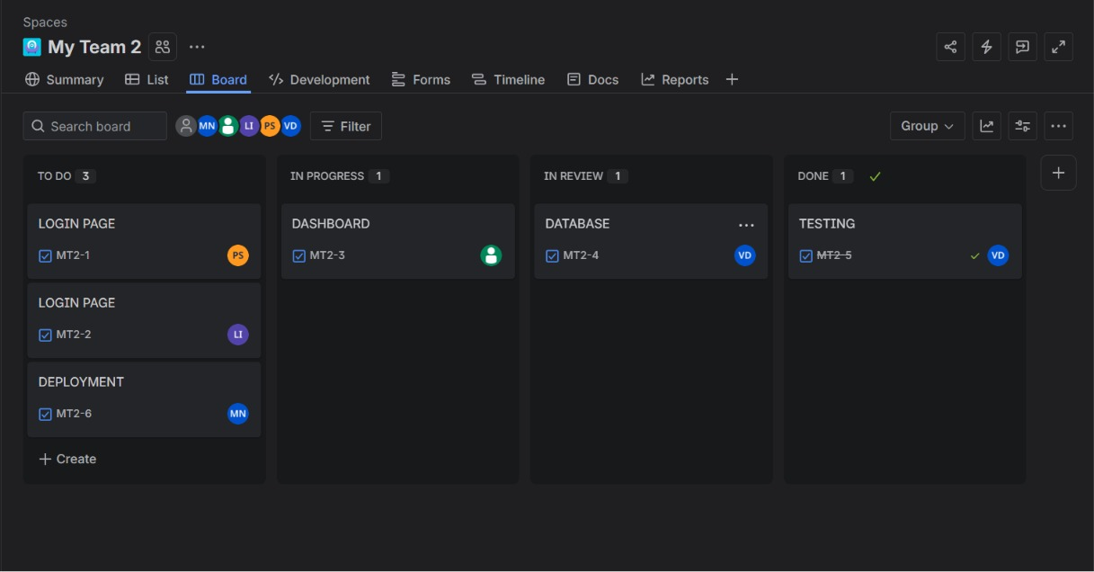
Experiment 2:
Sketch a Simple Prototype of a Bus Ticket Booking System using
Figma Tool
Output:
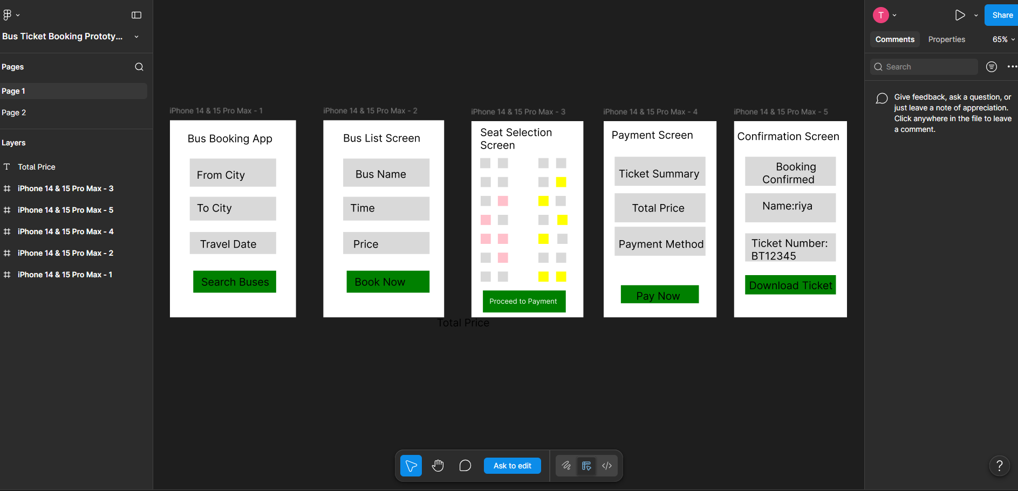

Experiment 3:
The stakeholders have conflicting views on the user interface design
for an E-Commerce mobile app. Create a prototype using Figma tool
to discuss with the stakeholders to get their feedback and approval.
Output:
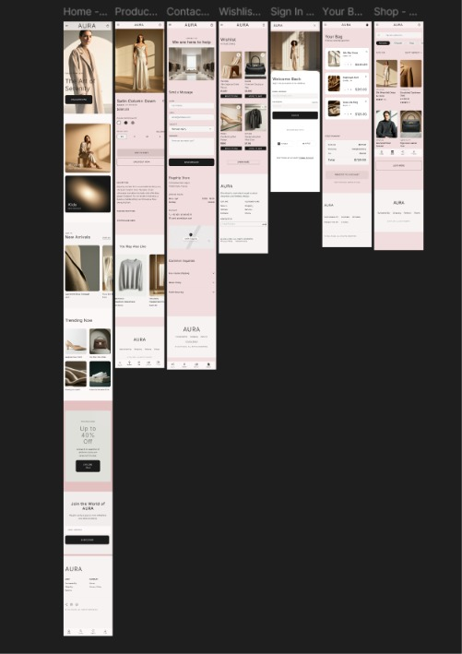
Experiment 4:
The string is a sequence of characters placed in double quotes (” “).
Performing different operations on string data is called String
Handling. Strings are immutable. Whenever a change to a String is made,
an entirely new String is created. If we want to store a group of characters
we can use a char array. String provides various methods to perform
different operations on strings. Using Raptor draw a flowchart to display
the total number of characters in the string and returns it.

Output:
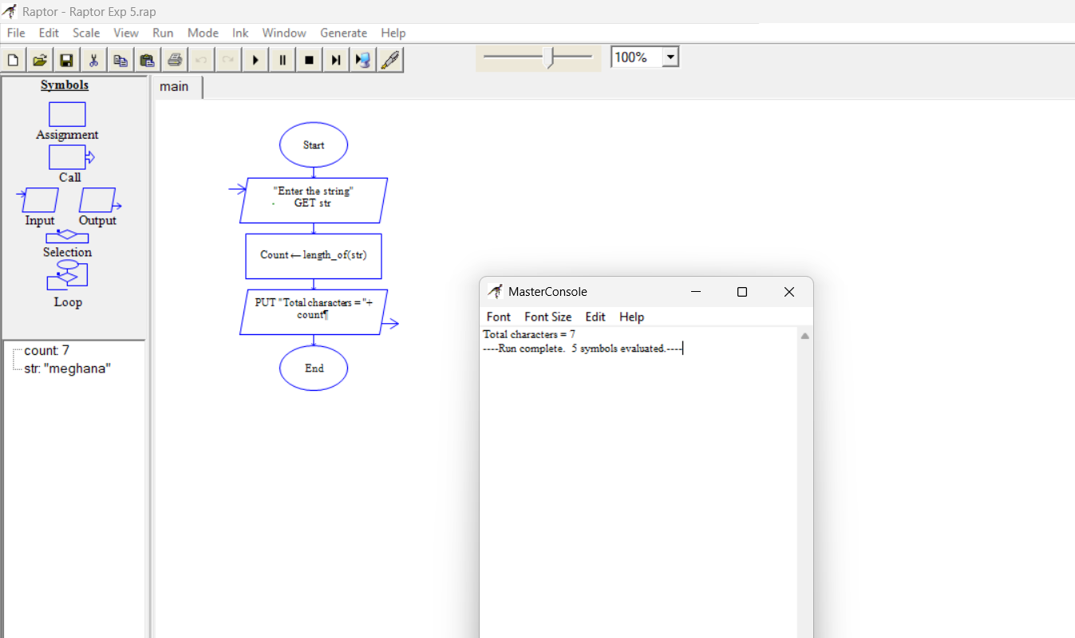
Experiment 5:
Using Raptor – Draw and validate a flowchart for a given string of lower
case English alphabets. One can choose any two characters in the string
and replace all the occurrences of the first character with the second
character and replace all the occurrences of the second character with the
first character. Using Raptor draw and validate the flowchart
lexicographically smallest string that can be obtained by doing this
operation at most once.
Output:
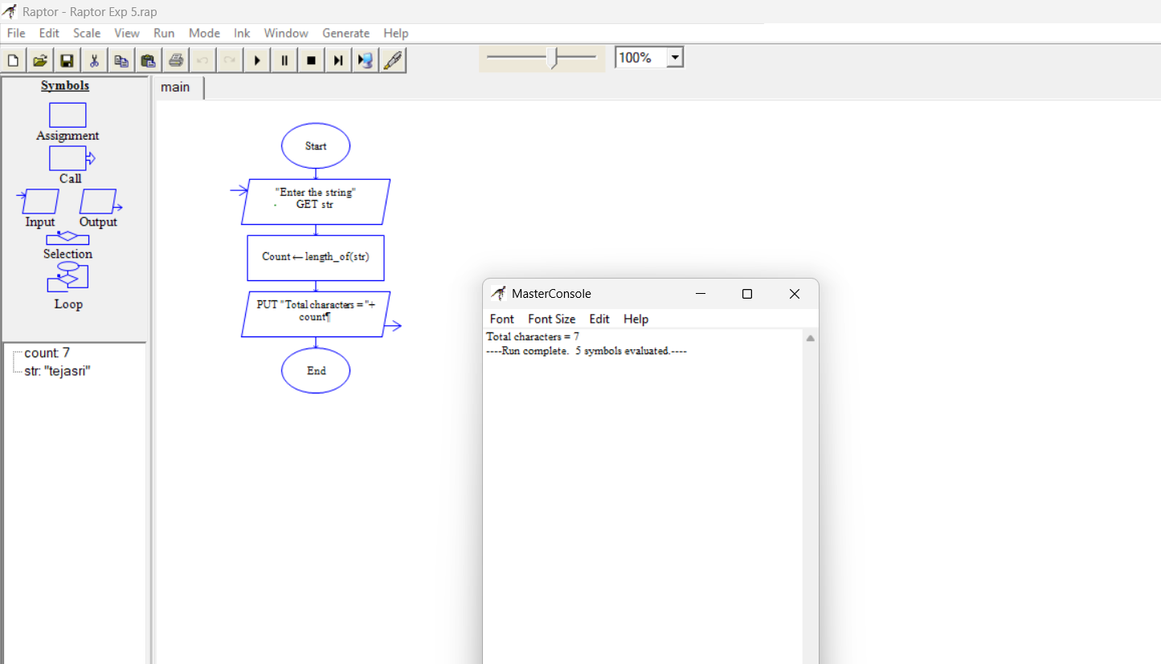
Experiment 6:
An online food delivery platform enables customers to browse restaurants,
view menus, place food orders, make online payments, and track delivery
status. Restaurants use the system to manage their menus and update order
status, while delivery agents are responsible for accepting delivery
requests and updating delivery progress. Design a Class Diagram, Use case
Diagram and Activity Diagram for the Online Food Delivery System
showing the relevant classes, their attributes, methods, and relationships.
Output:
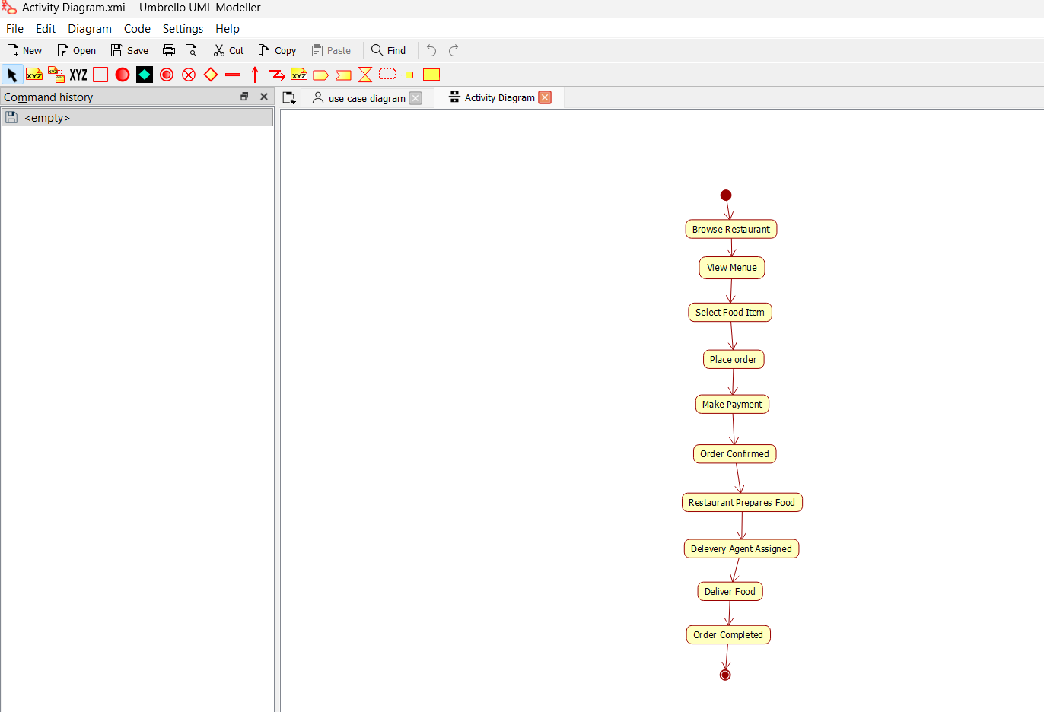
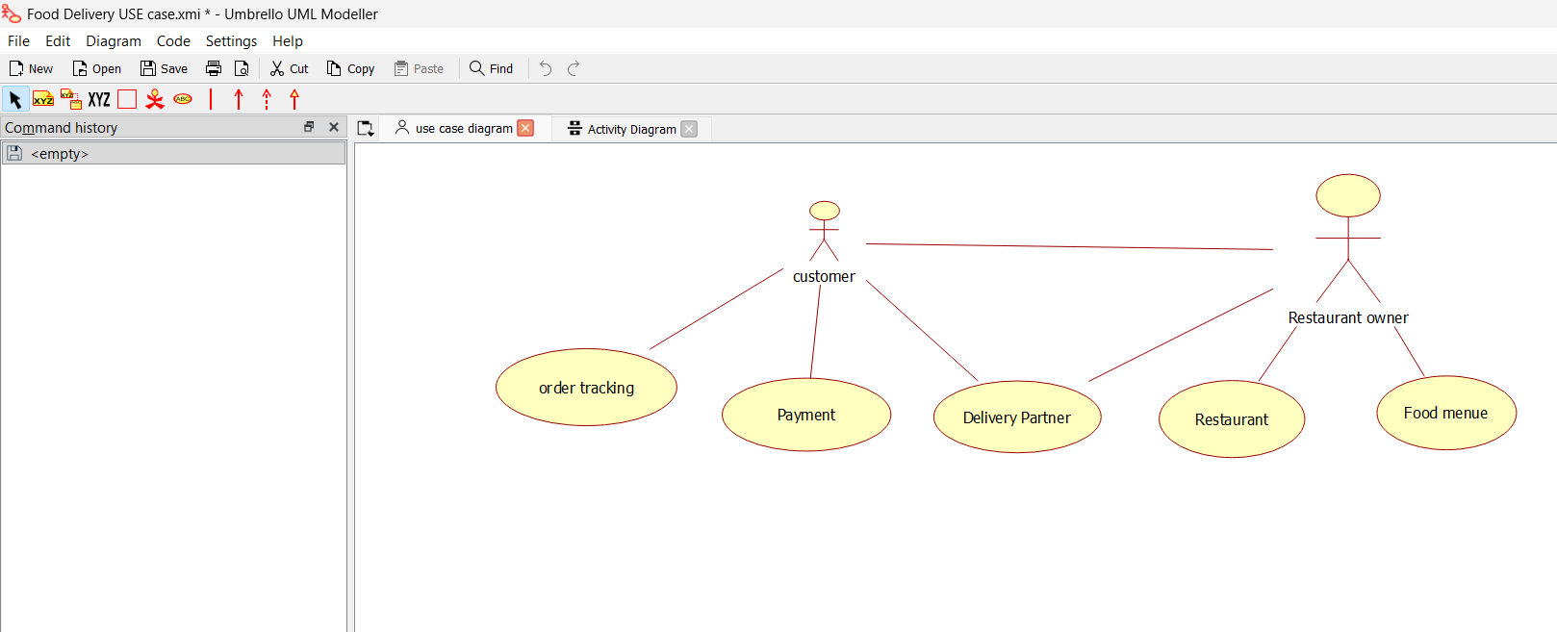
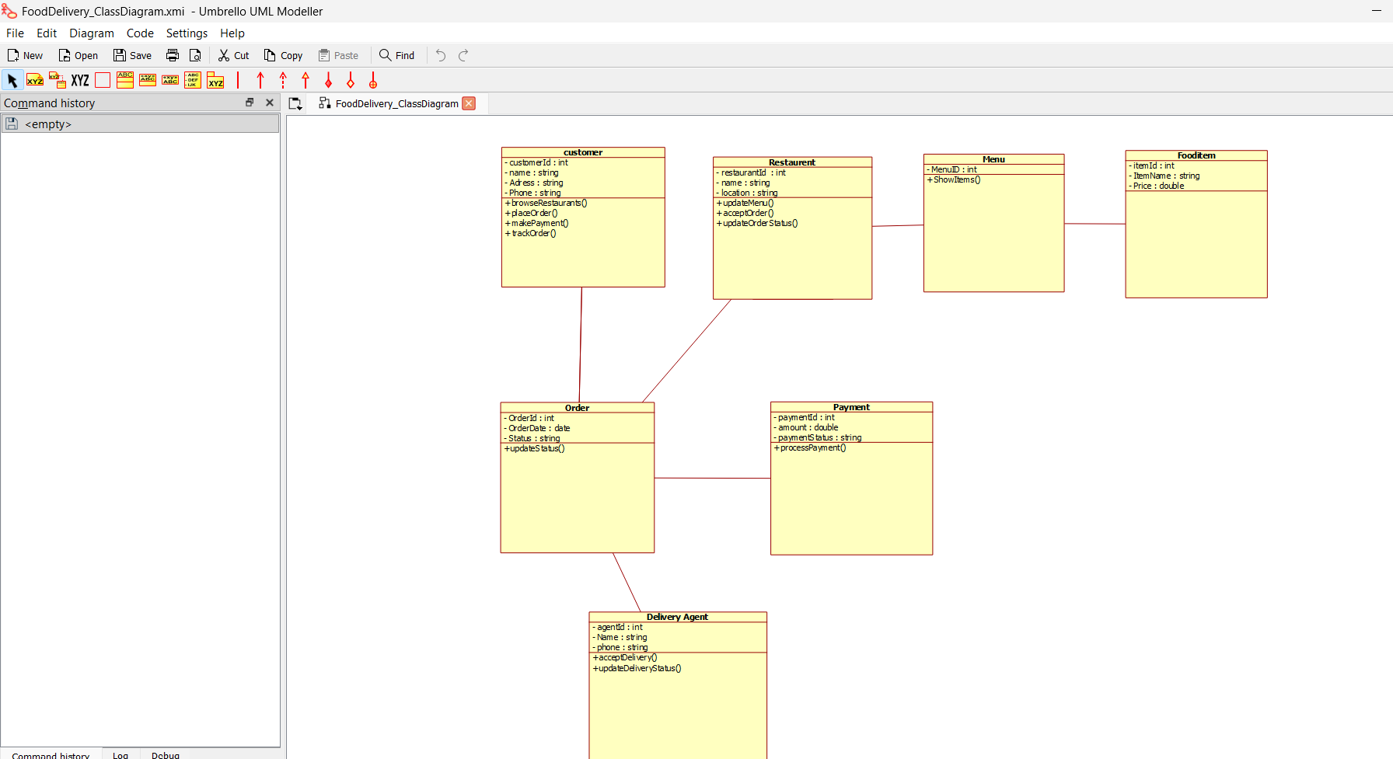
Experiment 7:
A college employs a large number of security personnel who are assigned
duties at various locations across the campus. Each security person follows
a duty schedule that includes date, duty start time, duty end time, and
assigned location, ensuring that every campus location is covered. If a
security person takes leave, it is recorded manually, and at the end of each
month, salaries are calculated based on duties performed and leaves taken.
Since manual handling of duty allocation, leave management, and salary

Output:
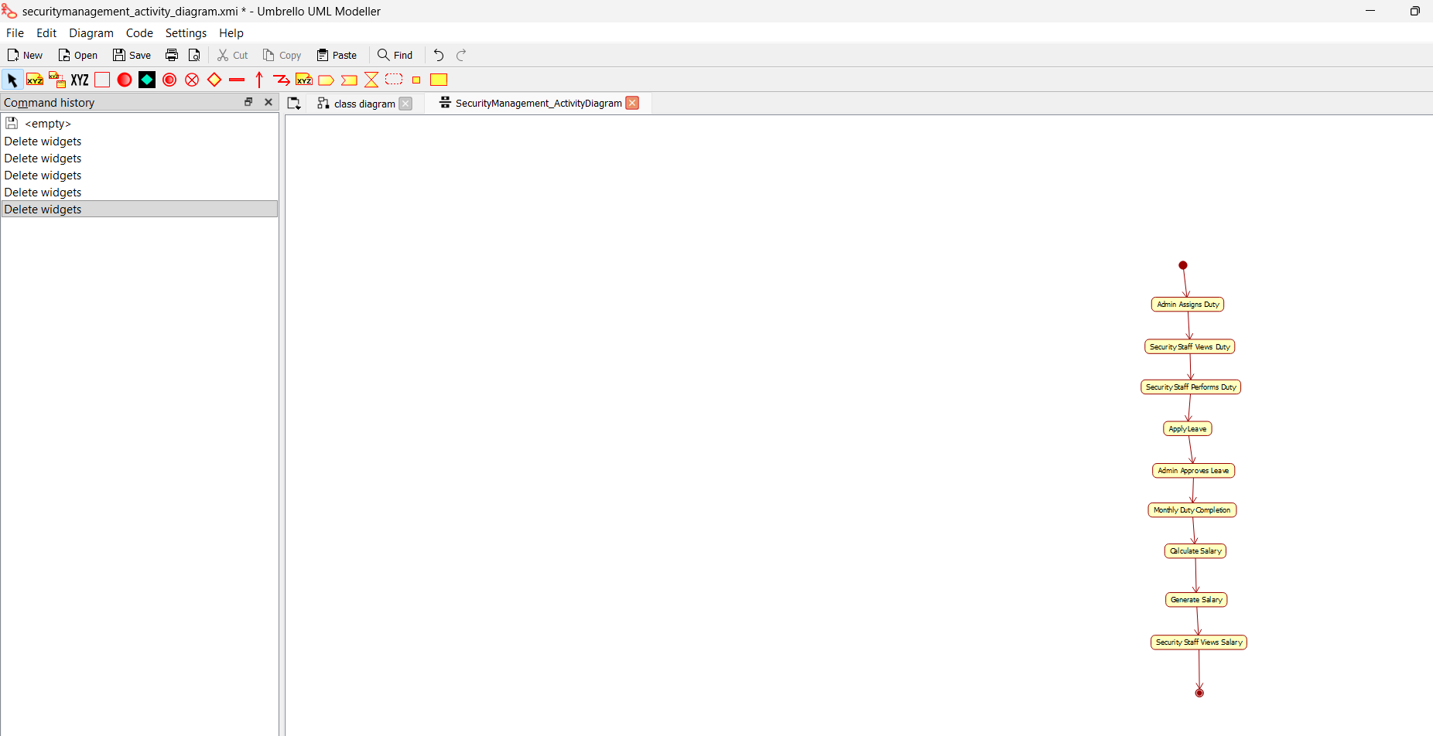
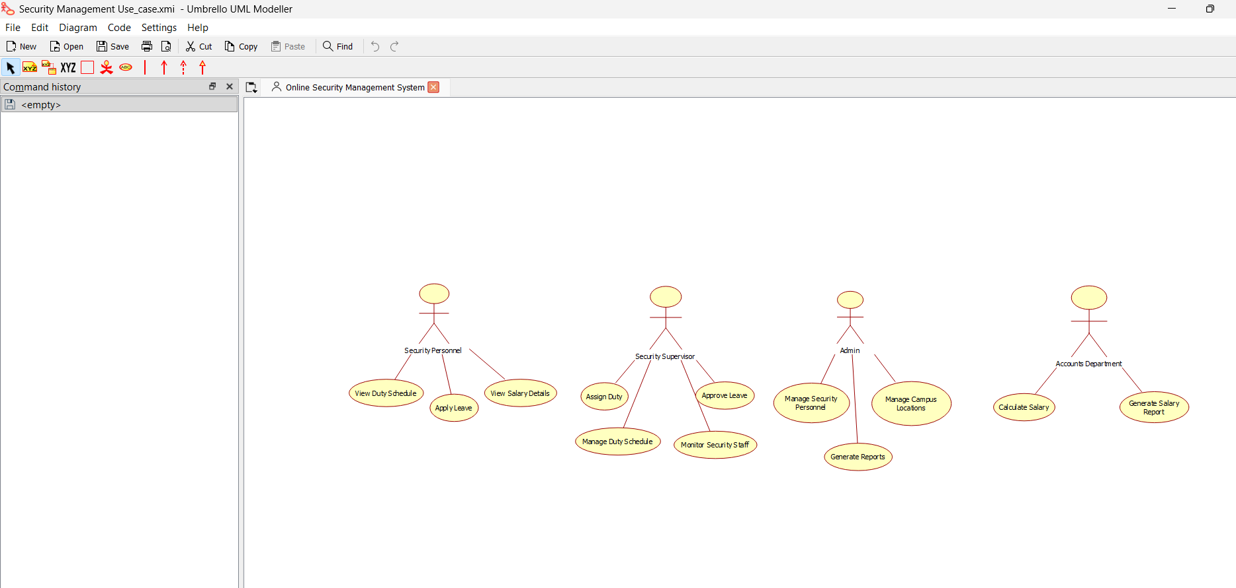
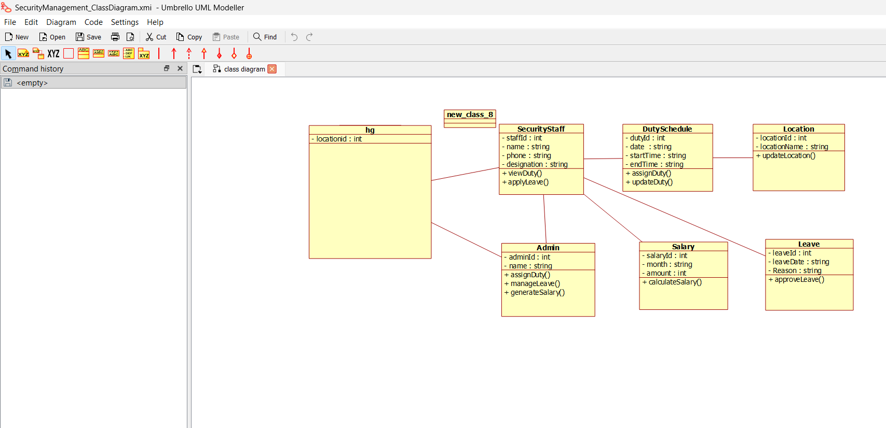
Experiment 8:
Cyclomatic Complexity in Software Testing is a testing metric used for
measuring the complexity of a software program. It is a quantitative
measure of independent paths in the source code of a software program.
Cyclomatic complexity can be calculated by using control flow graphs or
with respect to functions, modules, methods or classes within a software
program. Cyclomatic complexity for a flow graph G is V(G)=E-N+2.
Cyclomatic complexity is a software metric (measurement), used to
indicate the complexity of a program, Cyclomatic complexity = E - N +
P where, E = number of edges in the flow graph, N = number of nodes in
the flow graph, P = number of nodes that have exit points. Find Cyclomatic
Complexity for a graph having number of edges as 17, number of nodes as
13 and number of predicate nodes in the flow graph as 5.
Output:
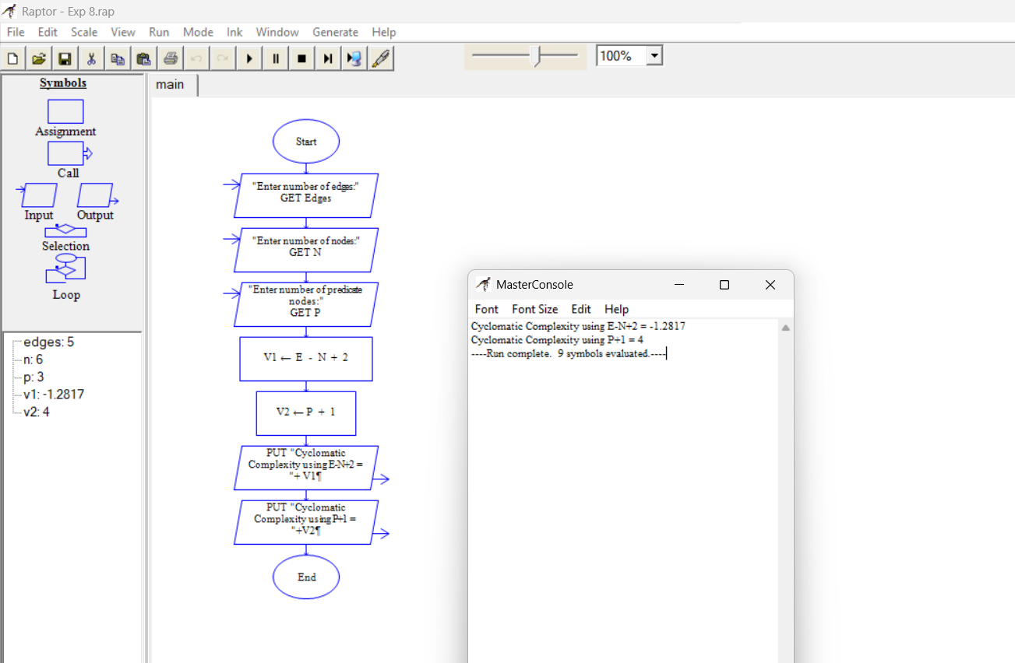
Experiment 9:
Create a Scrum Project in Jira.
• Add a backlog with at least 5 items (e.g., "Create user
registration page", "Develop API for login").
• Prioritize the backlog and create a 1-week sprint.
• Move backlog items into the sprint and start the sprint.
• Finally show the Screenshot of the sprint board at the start and
end of the sprint.

Output:
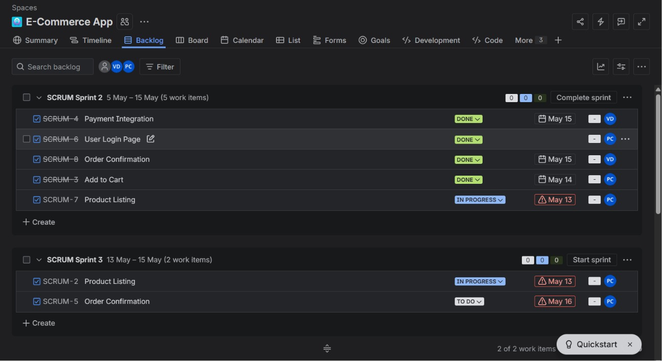
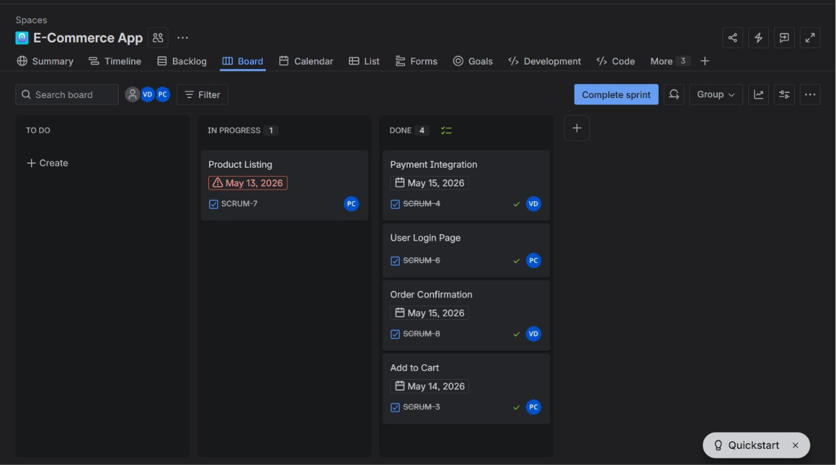
Experiment 10:
Use the following requirements for a Library Management System:
• Add a feature to search books by title and author.
• Implement an online book reservation system.
• Generate monthly reports on borrowed books for
administrators.
• Enable email notifications for overdue books.
• Add support for QR code scanning for borrowing and
returning books.
• Create a user-friendly dashboard for librarians.
• Allow users to review and rate books.
• Integrate a chatbot for user assistance.
• Develop a mobile app version of the system.
• Provide multi-language support.
Categorize each requirement using MOSCOW Method (Must-Have,
Should-Have, Could-Have, or Won’t-Have) based on the following
criteria:
• Impact on the users and stakeholders.
• Feasibility considering time, budget, and resource constraints.
Finally Submit the completed Google Sheet or Excel file with all
requirements categorized and justified.
Output:
